**Steven J. McGee Distributed Systems Architect / Consultant / Patent Applicant**

June 2004 – March 2018 Simple Always Wins Concepts LLC SAW Concepts LLC (deactivated)

Defense Contractor for Validity Systems, SAIC x 2, MITRE, BAE Systems 1996 – 2002

Masters of Science Information Systems Western International University 3.85 GPA 93 - 96

B.A. Psychology, Business Concentration Indiana University of Pennsylvania 1978 - 1992

United States Army Signal Corps Officer 11 years 82 – 93 / ROTC Full Scholarship Recipient

June 2003 – Present: Patent applicant USPTO 13/573,002: The Heart Beacon Cycle Time – Space Meter Adaptive Procedural Template (checklist of tools, processes, platforms, protocols… useful to form Distributed Autonomous Groups DAGS synchronized in time – space

Presenter: International Conference Complex Systems ICCS New England chapter 2006

Documents / Description / Sources: Github: <http://github.com/Beacon-Heart>

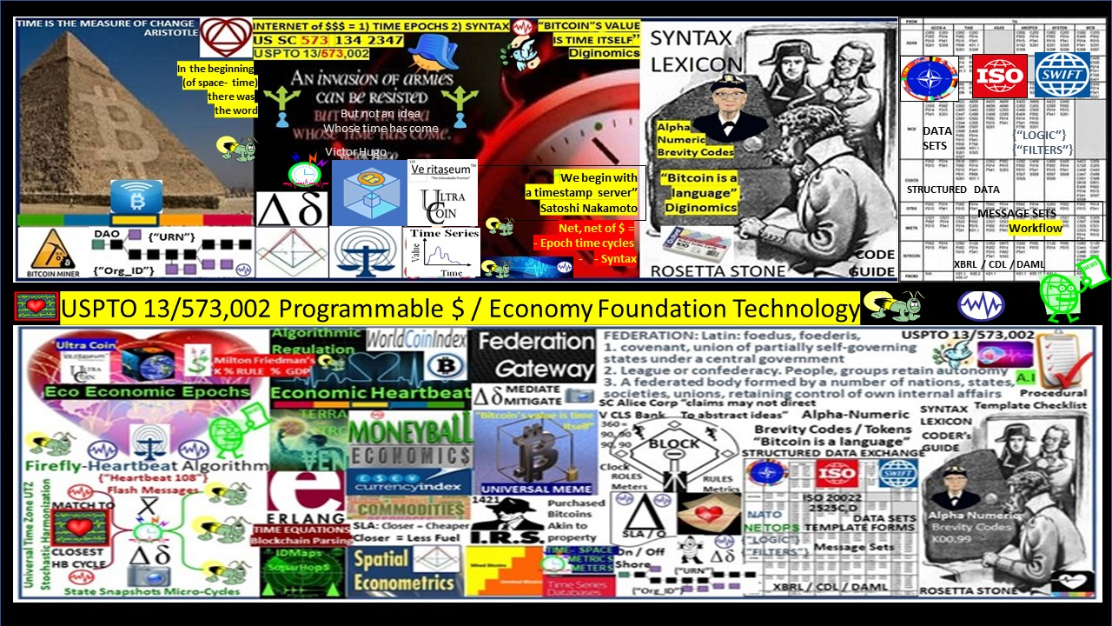Figure 1: Foundation technology for programmable money for the programmable economy

**FIGURE 2: The Great / Greater Reset (s)… standing on the shoulders of giants**

**Globalization involves multi-national corporate entities vying for control of regional resources. It follows that a proven strategy to identify, track, and monitor resources regionally within the global economic matrix is needed. Bitcoin cryptocurrencies as programmable money and the internet's heartbeat, heartbeat messages timed to harvest data during micro economic cycles then aggregated into a composite economic heartbeat pulse which is a clear and present opportunity to implement a simple SLA Service Level Agreement: closer is cheaper given closer = less fuel, carbon consumed promoting produce and consume locally. / Heart Beacon Cycle Ecologically Sustainable Economic Epochs for trade equity, ecologic sustainability, economic stability.**

Mega banks & FINTECH giants are forming teams to prove they have established / created foundation technology for programmable money i.e., Bitcoin, cryptocurrencies, DeFi Q: What is foundation technology for the net, net of programmable $$$ money - cryptocurrencies - economy Foundation technology consists of: 1) Epoch time cycles 2) Syntax used / not during epoch time cycles. USPTO 13/573,002: Adaptive Procedural Template Framework: checklist: ideas, algorithms, processes, procedures, metrics, meters, signal & telemetry structured data Github: <http://github.com/Beacon-Heart>

"Build a new model that makes the old model obsolete" RBF

"Focus your energy in building the new, not fighting the old" Socrates

USPTO 13,573,002: The Heart Beacon Cycle Time - Space Meter Adaptive Procedural Template (checklist): A checklist of ideas, processes, protocols, algorithms, best practices used to form a trade federation on the cryptocurrency blockchain helping code programmable money for the programmable economy with a focus on a unit of value based on a statistical mean of GDP index pacing items (Gross Domestic Product) e.g., crops, precious, industrial metals commodities, and crypto currencies to valuate a FEDCOIN, WORLDCOIN programmable money for the programmable economy in light of the currency, global economic reset of 2025.

Figure 3: Checklist of ideas, processes, procedures to achieve common goals

Question: what constitutes foundation tech for [#DeFi](https://www.linkedin.com/feed/hashtag/?keywords=defi&highlightedUpdateUrns=urn%3Ali%3Aactivity%3A6967102147989532673) / programmable $$$ ?  
  
Teams are forming to win the DeFi Distributed Finance / programmable $$$ money IP Intellectual Property wars. The winning team will prove that their IP intellectual property filings established FOUNDATION TECHNOLOGY  
.  
Question: How is foundation tech described through the lens of SCOTUS 2014 "Alice in Wonderland" ruling? "Claims may not direct towards abstract ideas"  
  
THESIS: All things internet, internet of programmable money are formed using:  
  
1. Time epochs created by oscillating quartz crystal silicon chips  
  
2. Syntax used / not used as programming instructions during epoch time cycles  
  
THESIS SUMMARY: All things internet, net of money blockchains are formed by unicast, multicast, anycast protocols. Programmable money’s improvements are in cryptography. Blockchains are formed by unicast, multicast, anycast and workflow filters. Programmable money’s improvements are in cryptography. Internet 3.0 and the new web will be based on the original structure described by Stanford University. There are no packets, frames, layers, blocks, shards, graphs, hash graphs “bots”, “motes”, … or Satoshi's traversing the net, stored in a blockchain cube. Transactions are unicast, multicast, or anycast (workflow). The afore mention terms are non-existent fabrication.

We need an Eco sustainable Economic Heartbeat with incentives systemically coded into the programmable economy applying consistent time - space metrics, meters and a syntax lexicon library. The German military made a suggestion circa 2003 namely OOTW Operations Other Than War of use of Battlefield Digitization for humanitarian relief, digital dashboards displaying updates to an EIN Earth Intelligence Network drawn from a system of distributed systems etc.

Figure 4: Eco sustainable Economic Heartbeat / Adaptive Procedural Template (checklist)

USPTO 13/573,002 Checklists (adaptive procedural template in patent application parlance) are visually boring and do not capture attention so this graphic is a picture comprised of symbols and graphics of a checklist of useful tools, procedures, processes, algorithms, ideas that a trade federation would agree to use to achieve, maintain their goals of the trade federation.

USPTO 13/573,002 HEART BEACON CYCLE ADAPTIVE PROCEDURAL TEMPLATE USE CASES:

1. Eco sustainable Economic Heartbeat / Programmable Economy Namespace

2. Distributed Autonomous Organization DAO support. The term DAO was coined by military think tank RAND Corporation circa 2001. Military’s always operate as organizations. NATO operations are usually distributed across many time zones and involve language translations.

3. Common signaling, telemetry, symbol, and data element sets help DAO’s stay synchronized. Joining autonomous trade federations using agile, adhoc [NetOps](https://en.wikipedia.org/wiki/NetOps) is an option to formal merger.

4. A key goal is to support federations: from Latin: foedus, gen.: foederis, covenant characterized by a union of partially self-governing states or regions under a central (federal) government.

5. Spatial econometrics. Geo-spatial, temporal metrics and meters will be universally consistent and synchronized across time zones. Micro to macro-cycle updates maintain system of systems

6. Universal Time Zone UTZ proposal using via improvement to the University of Bologna / Hungary’s firefly inspired heartbeat synchronization algorithm by matching the firefly synchronization pulse to the closest OPTEMPO Heart Beacon Cycle.

7. The "Grail" A sync'd shared situational awareness view among a system of systems showing statistical mean value indexes can be achieved by reuse of improved net centric warfare methods joined with establishing a universal event bus using firefly-inspired heartbeat synchronization

8. Supreme Court Alice Corp Vs CLS Bank compliant universal memes describe sync delta cyclic changes: describes linear sequential, geo-spatial temporal intensity radius hop count econometric metrics and meters where closer is shorter and closer is faster – eco sustainable

9. Algorithmic regulation: firefly inspired heartbeat synchronization algorithm in stocks, currency exchanges is a segue to algorithmic regulation. Improving temporal trade parity between Bitcoin Blockchain & conventional stock exchanges by using the firefly-heartbeat algorithm to take trade speed samples among trade populations across time zones to establish consensus among disparate trade protocols, optimal trade speed / frequency as a statistical mean. Define time intervals with discrete start, stop, TTL Time To Live trade windows using commands embedded within </108> heartbeats, heartbeat messages organic to all systems.

10. Supporting economist Milton Friedman’s K% rule where a “FEDCOIN / WORLDCOIN currency could be derived from sampling lead economic indicators across a global, universal event bus applying the firefly-heartbeat algorithm tracking changes, updating statistical means

11. Big Data as the “Next Oil”: Establishing a consistent <tag> context library / lexicon and time stamping data by organization <Org_ID> and by data class type and by resource type to form a universal syntax, code, date element, tag Rosetta Stone and reference for coders, programmers

12. Universal meme metaphor for coders, programmers given all things internet are formed using time cycles / syntax as instructions i.e., universal Bitcoin blockchain meme mediation

Figure 5: The Financial Nostradamus / FutureMan IP fusion

**Figure 6: Nobel Prize Winning Economist’s K% rule / USPTO 13/573,002 fusion**

The K-Percent Rule was a proposal by economist Milton Friedman that the central bank should increase the money supply by a constant percentage every year. The K-Percent Rule was a proposal by economist Milton Friedman that the central bank should increase the money supply by a constant percentage every year. The K-Percent Rule proposes to set the money supply growth at a rate equal to the growth of gross domestic product (GDP) each year. In the United States, this would typically be in the range of 2-4%, based on historical averages. The K-percent rule, proposed by economist and Nobel Prize winner Milton Friedman Milton Friedman Milton Friedman was an American economist who advocated for free-market capitalism. Friedman's free-market theories influenced economic, is a monetary policy rule that requires central banks to increase the money supply irrespective of the condition of the economy. Supporting economist Milton Friedman’s K% rule where a “FEDCOIN / WORLDCOIN currency could be derived from sampling lead economic indicators across a global, universal event bus applying the firefly-heartbeat algorithm tracking changes, updating a statistical mean of a GDP commodity index

"The economy of imaginary wealth is being inevitably replaced by the economy of real and hard assets'' Vladamir Putin

**Figure 7: UTZ Universal Time Zone stochastic harmonization, synchronization**

The world’s system of systems need to be time-space synchronized, stochastically harmonized across the one world, global UTZ Universal Time Zone via heartbeat messages using universally shared, standards based OPSCODE brevity codes drawn from a universal structured data exchange syntax lexicon with over 300 use case templates e.g., NATO’s lexicon library. NIST’s QRNB intent is to be interoperable with other QRNB’s, therefore, this Max Planck Institute / Announcement is germane to a discussion of a one world government / one world economic system of systems: distributed quantum computers – will need (UTZ Universal Time Zone) stochastic harmonization.

Universal Time Zone UTZ proposal using via improvement to the University of Bologna / Hungary’s firefly inspired heartbeat synchronization algorithm by matching the firefly synchronization pulse to the closest OPTEMPO Heart Beacon Cycle.

Figure 8: NIST Quantum Random Number Beacon / USPTO 13/573,002 fusion

The programmable #economy will be anchored by quantum computing NIST's Quantum Random Number Beacon combined with the Heart Beacon Cycle Time – Space Meter Adaptive Procedural Template checklist. Non-repudiation of events / transactions at any time, space, place in the future will be expected and required by end users and governments.

Programmable #money / #economy… gold, #Bitcoin as “digital gold” — fool’s #gold? How will programmable money for the programmable economy be coded? A one world #currency needs a stochastically harmonized, synchronized Universal Time Zone UTZ / event bus

The NIST Randomness Beacon Broadcasts a randomness pulse every 60 seconds Each pulse commits to a fresh 512-bit random string Each pulse is time-stamped and signed. Beacon periodically outputs a pulse containing 512 fresh random bits, time-stamped, signed and hash-chained. For example, each pulse also pre-commits to the randomness to be released in the next pulse. The latter enables users to securely combine randomness from different beacons. The Beacon protocol also specifies the interface for users to interact with the Beacon to obtain information about past pulses. A randomness beacon produces timed outputs randomness

Bretton Woods Three: @26:37 "we are entering a system called Bretton Woods Three: a system dominated by #COMMODITIES" statement by former Federal Reserve Board member Youtube: <https://lnkd.in/eN4vGP58> #commodities #gold #currency #reset #CBDCs

**Figure 9: universal meme / metaphor for myriad blockchain algorithm memes / metaphors**

**Bitcoin blockchain blocks, agents, motes, bots, heartbeat, beacon are metaphors for intervals, time cycles available to process / not process SYNTAX. The internet is coded, programmed using time cycles to process instructions, commands etc. It follows that the key to achieving consistency, interoperability among myriad memes and establishing a consistent, systemic one world economic system of systems is to focus on two main common building blocks — time cycles and syntax parsed as instructions.**

**Given crypto blockchain myriad memes, metaphors "hashgraph" "Ether gas", we are creating new data elements in new syntax lexicons. DoD / NATO's structured data exchange (mapped to symbol sets for A.I - man - machine interface) took decades to achieve consensus -why reinvent the wheel? SOURCE:** [**http://en.wikipedia.org/wiki/SIMPLE_(military_communications_protocol)**](http://en.wikipedia.org/wiki/SIMPLE_(military_communications_protocol))

FIGURE 10: SCOTUS Alice Corp Vs CLS Bank “claims may not direct towards abstract ideas”

Bitcoin blockchain blocks, agents, motes, bots, heartbeat, beacon are metaphors for intervals, time cycles available to process / not process SYNTAX. The internet is coded, programmed using time cycles to process instructions, commands etc. It follows that the key to achieving consistency, interoperability among myriad memes and establishing a consistent, systemic one world economic system of systems is to focus on two main common building blocks -- time cycles and syntax. Alice Corp. v. CLS Bank International, 573 U.S. 134 S. Ct. 2347 (2014), United States Supreme Court decision about patentable subject matter (patent eligibility). The patents were held to be invalid because the claims were drawn to an abstract idea and implementing those claims on a computer was not enough to transform that idea into patentable subject matter. In our opinion, physical is the opposite of abstract.

**Alice** **Corp**. **v**. **CLS** **Bank** International, 573 U.S. 208 (2014) compliant ruling “claims may not direct towards abstract ideas”. Physical (baseball meme) is the opposite of abstract

[LINK](https://en.wikipedia.org/wiki/Alice_Corp._v._CLS_Bank_International) WIKIPEDIA: https://en.wikipedia.org/wiki/Alice_Corp._v._CLS_Bank_International

FIGURE 11: FIREFLY HEARTBEAT SYNCHRONIZATION / World Economic Heartbeat

**Firefly inspired Heartbeat Synchronization: in a paper entitled Fireﬂy-inspired Heartbeat Synchronization in Overlay Networks by the University of Bologna Trento Italy along with the University of Szeged, Hungary: “Heartbeat synchronization strives to have nodes in a distributed system generate periodic, local “heartbeat” events approximately at the same time. The heartbeat synchronization protocol for overlay networks is inspired by mathematical models of ﬂash synchronization in certain species of ﬁre ﬂies. Nodes send ﬂash messages to their neighbors when a local heartbeat triggers. Fireflies adjust the phase of their next heartbeat based on incoming ﬂash messages using an algorithm inspired by mathematical models of ﬁre-ﬂy synchronization. Heartbeat synchronization strives to have nodes in a distributed system generate periodic, local “heartbeat” events approximately at the same time. It differs from classical clock synchronization in that nodes are not interested in counting cycles and agreeing on a ID of a current cycle. There is no requirement regarding the length of a cycle with respect to real time as long as a length is bounded, and all nodes agree on it eventually.**

**Use Case:** Economic Reset solution: form economic trade federations incentivizing environment friendly business practices leveraging Bitcoin's micro-payment capabilities supporting the TERRA Trade Reference Currency TRC demurrage handling charge. Closer is cheaper, less fuel, < C02 carbon emission in smart contract Service Level Agreements.

A picture containing text

Description generated with high confidence**FIGURE 12: TERRA Trade Reference Currency / Crypto micro payment Demurrage fees**

Nobel Prize winning Economist Milton Friedman’s K% rule is what I call an “economic heartbeat” K-Percent Rule. DEFINITION of ‘K-Percent Rule’. The K-Percent Rule was a proposal by economist Milton Friedman that the central bank should increase the money supply by a constant percentage every year. The K-Percent Rule proposes to set the money supply growth at a rate equal to the growth of real GDP each year. K-Percent Rule — Investopedia <http://www.investopedia.com/terms/k/k-percent-rule.asp>

[Economic](https://twitter.com/hashtag/Economic?src=hash) [RESET](https://twitter.com/hashtag/RESET?src=hash) is a mathematical certainty. Do we [RESET](https://twitter.com/hashtag/RESET?src=hash) the global system of systems as is or do we re-engineer our world using NATO / DOD system of systems engineering framework standing on the shoulders of giants (Edison, Lietaer, Friedman) swords to plowshares?

**IF climate change causes a drop in crop commodity by 20–25 % while population grows, THEN this condition will become a matter of national security. THEN this will require revisiting Belgian Economist Bernard Lietaer’s TRC Trade Reference Currency ELSE face chaos by not leveraging proven system of systems & tactics**

**Satoshi Nakamoto’s Bitcoin key building block is a time stamp server. Satoshi Nakamoto: "Bitcoin is intended to be paired with the market place" "the blockchain stores references to market indexes"**

**Demurrage: term used in currency trading to denote cost of currency ownership and/or storage. cost of carrying money… considered superior to interest payments, as it stimulates currency circulation and economic growth. “In a physical sense, demurrage represents a delay that occurs during the transportation of goods via truck. When this happens, the trucking firm delivering the product can opt to pay a flat fee to the receiver to cover any loss incurred as a result of the delay. This fee can be assessed on an hourly basis. Or in the case of gold, demurrage is simply the costs associated with storage of bouillon.** [**LINK**](https://investopedia.com/terms/d/demurrage.asp)[**https://investopedia.com/terms/d/demurrage.asp**](https://investopedia.com/terms/d/demurrage.asp)

Fig 13: Edison proposed a commodity backed currency based on crop commodities 1921

Thomas Edison’s Monetary Option:

<LINK>: <https://www.supermoney.com/2014/06/thomas-edisons-view-money/>

**Economist Milton Friedman predicted the rise of a computer capable of automatically adjusting the inflation rate of money. This is precisely what we see in the case of bitcoin, as a regulatory algorithm intelligently adjusts the mining difficulty to make the issuance of blocks more or less easy depending on the demand for network hashing power. No money system we have seen to date can claim it is chronologically regulated. The universal construct of time is the backbone of the cryptocurrency digital economy. Investopedia K % Rule** [Source](https://www.investopedia.com/terms/k/k-percent-rule.asp)**: https://investopedia.com/terms/k/k-percent-rule.asp**

A close up of text on a white background

Description generated with very high confidence

Figure 14: Syntax Lexicon Library Rosetta Stone adapted swords to plowshare from NATO

Common syntax library of various Message Text Formats MTF to enable universal signaling / telemetry among a system of systems is ESSENTIAL. Decades of research at the taxpayer's expense into structured messaging / structured data exchange where the location, type of data identified by table number will help accelerate the process of organizing syntax into categories from disparate systems into data set reference repositories. Many semantic, syntax tags will be reusable. The rules, roles and logic developed by years of research involving of thousands of subject matter experts solving real world issues is the value to be extracted from 300+ message sets. NATO stays synchronized across many languages and cultures so why reinvent the wheel?

MESSAGE CATALOG: The USMTF message library has over 300 messages to choose from to facilitate information exchange requirements. MTFs presenting data in a logical, well specified and unambiguous layout. MTFs are transmission medium neutral. The content of the Message Catalogue has been developed by military operators over the last 20 years. Messages are regularly maintained to keep pace with the latest tactics and doctrine.

**Military brevity codes and stock exchange codes are similar. security Identifier used in financial markets are: SYMBOL, CUSIP, ISIN, SEDOL, RIC Code,** Syntax Lexicon Library

Figure 15: UTZ TIME ZONE STOCHASTIC HARMONIZATION / SYNCHRONIZATION

We can synchronize ourselves, our cities, towns, cyber-communities in time — space for a common purpose: shared, common, ecologically sound, equitable… econometrics.

UNIVERSAL TIME - SPACE SYNCHRONIZATION: The Heart Beacon Cycle Time - Space Meter is intended to bridge humanity from our present condition to a higher consciousness described by Extra Terrestrial Groups and organizations like the Law of Time dot org with the Noosphere concept

"One people, one Earth, one Time": "The times we are living in require higher thinking. There has never in the history of the Earth been a time like this. We are now participating in what is called the biosphere-noosphere transition: When life on Earth evolves into an awakened planetary mind (noosphere)". See The Law of Time dot Org

**Figure 16: FEDCOIN / WORLD COIN Synchronization / stochastic harmonization**

One world currency for the one world government will require financial events stochastically synchronized, harmonized across the world's time zones and will need to represent a value index of the world's GDP Gross Domestic Product METHOD: Use Thomas Edison's commodity backed index recommendation 1921, Milton Friedman's K % rule, Economist Bernard Lietaer's TERRA TRC Trade Reference Currency concepts in concert with the firefly-heartbeat algorithm developed by the University of Bologna, University of Hungary. Economic Reset solution: form economic trade federations incentivizing environment friendly business practices leveraging Bitcoin's micro-payment capabilities supporting the TERRA Trade Reference Currency TRC demurrage resource handling charge. Closer is cheaper, < fuel, less C02 carbon emissions.

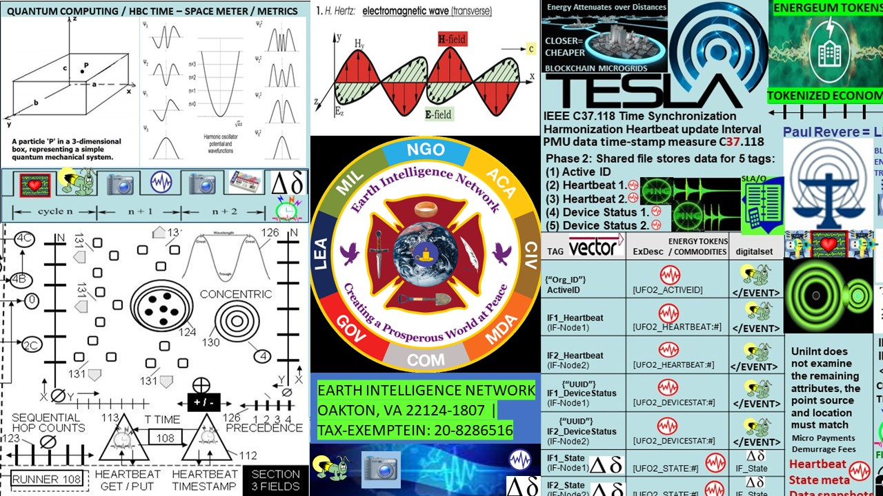

Figure 17: Data transmission via (wireless) electrical transmission

"One of the most important features of this invention will be the transmission of intelligence. It will convert the entire earth into a huge brain, capable of responding in every one of its parts. By the employment of a number of plants, each of which can transmit signals to all parts of the world, the news of the globe will be flashed to all points. A cheap and simple receiving device, which might be carried in one's pocket, can be set up anywhere on sea or land, and it will record the world's news as it occurs, or take such special messages as are intended for it. If you are in the heart of the Sahara your wife can telegraph you from Washington, and if the instrument is properly made you alone will get the message. A single plant of a few horse power could operate hundreds of such instruments, so that the invention has an infinite working capacity and will cheapen the transmission of all kinds of intelligence."

— Nikola Tesla

"Inventions of Tesla—A Man Whose Mind Works While He Sleeps.” The Boston Sunday Globe, Boston, Massachusetts, page 3. December 18, 1904.

Linda the Jersey Shore Medium "there may be a second invention"

**Github:** [**http://github.com/Beacon-Heart**](https://l.facebook.com/l.php?u=https%3A%2F%2Fgithub.com%2FBeacon-Heart%3Ffbclid%3DIwAR0J1G9mY7tI4mH7Zb2J67dQHK1uzUcNOlI0h9DshWOps_d4Ai4bChB19TE&h=AT1CKATHtBKVL_Qel0oNsC-xDRhRW0Gq0oFsKsCFExxOlVlw1LEURRxdZvQXJjPyFwj6JePYenLY_syfnZrWblyb7WErmOA6AxzdSna0HaIcyzZK8l6jFXqSECUEDO1ML-Nu&__tn__=-UK-R&c%5b0%5d=AT2n0GtlNOum0lFGBZLaRfWFbWafmsNS_qAShi3Te76cXS_CnXL_FeBbTqQiPvUwZqrT91X7v5TXVMW8TUXv3fkq3uM6fnLL530gKsNoMGUFFjLfm7qIFqVABvNTD8fugcCQEqnQABHKK-DRsJiX)

Angel List: <https://angel.co/heart_beacon>

Maven: <http://app.maven.co/profile/SHfEKnA9>

LINKEDIN: <https://www.linkedin.com/in/ecoeconepochs/>

FLOTE: <https://flote.app/user/Heart_Beacon>

Proton Email (secure) [ecoeconomicepochs@protonmail.com](mailto:ecoeconomicepochs@protonmail.com)